Jmecherie RC
Pop standard
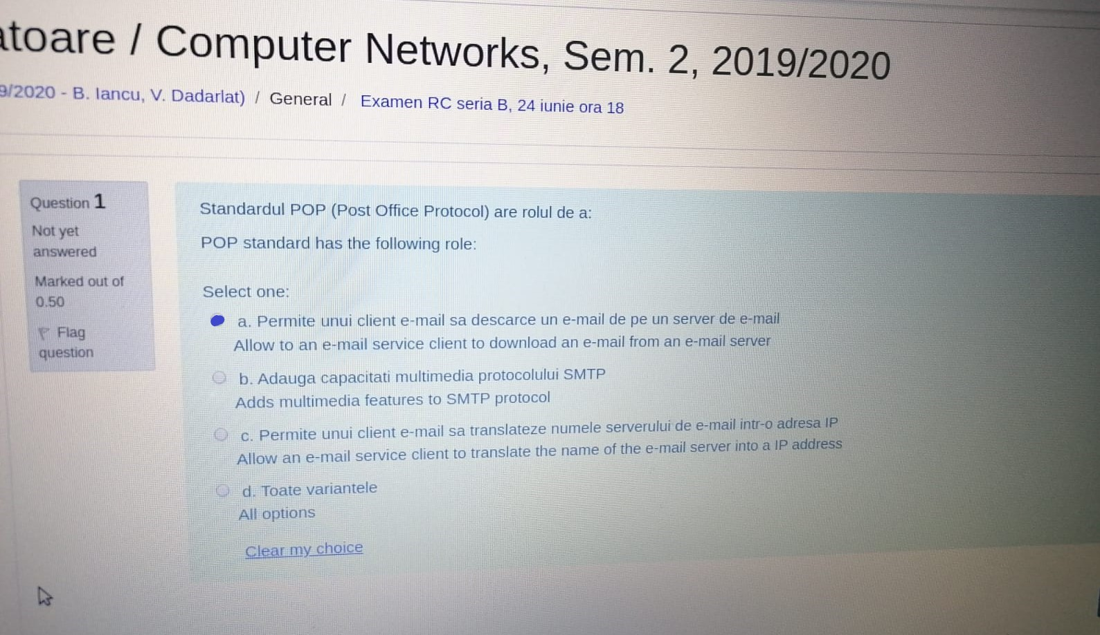
MIME standard
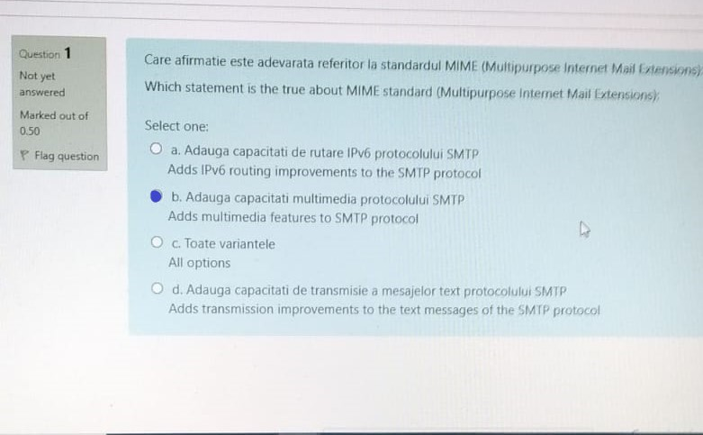
URL, top-level DNS domain
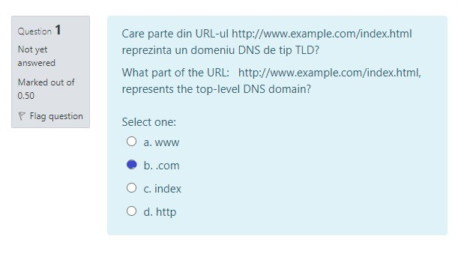
GET, PUT, POST
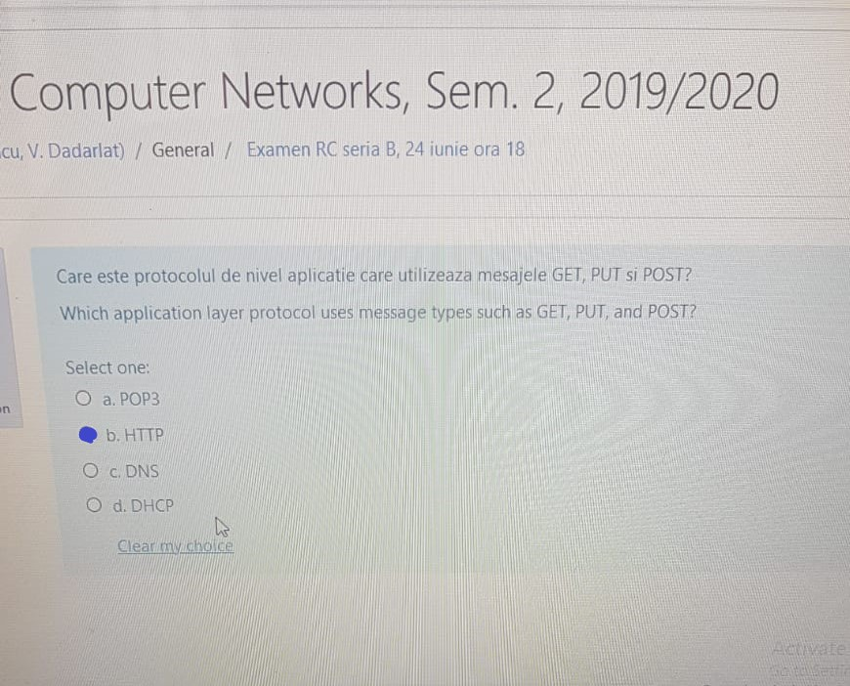
Main disadvantage of stop-and-wait flow control
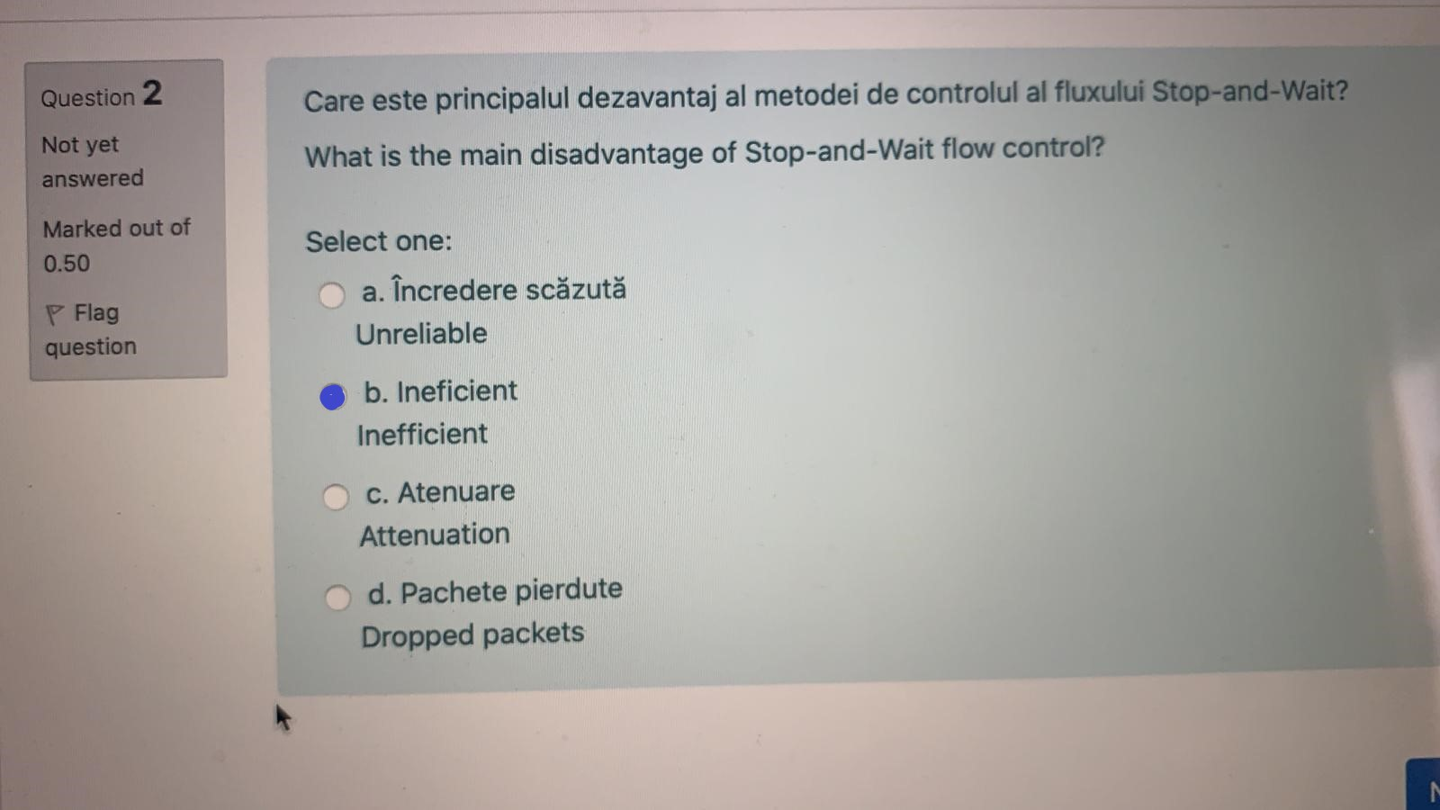
flow control is mainly a function of which iso/osi layer
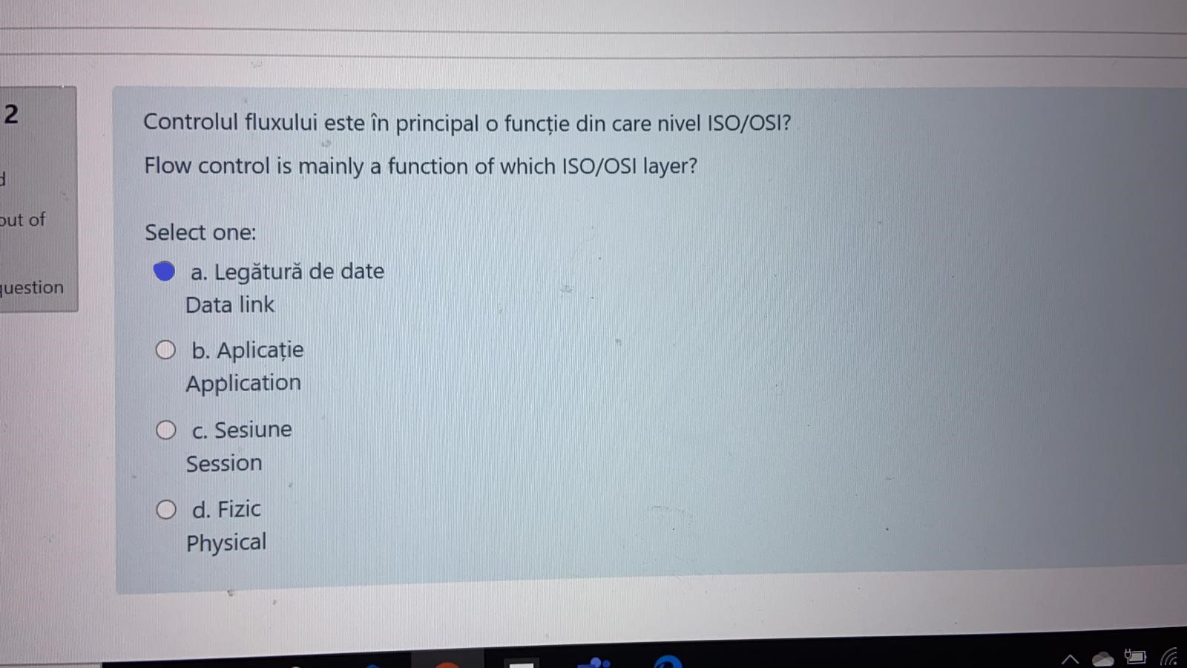
Stop-and-wait method of flow control, the sender sends how may frames at a time
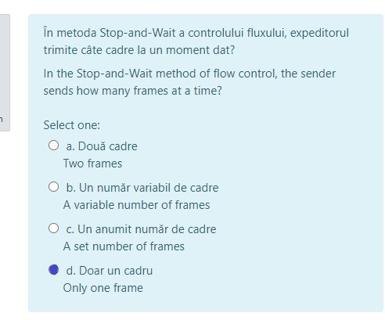
A sender was a sliding window of size 15
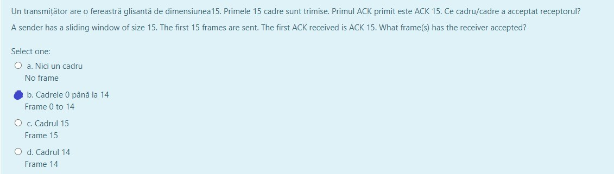
in TCP sending and receiving data is done as :
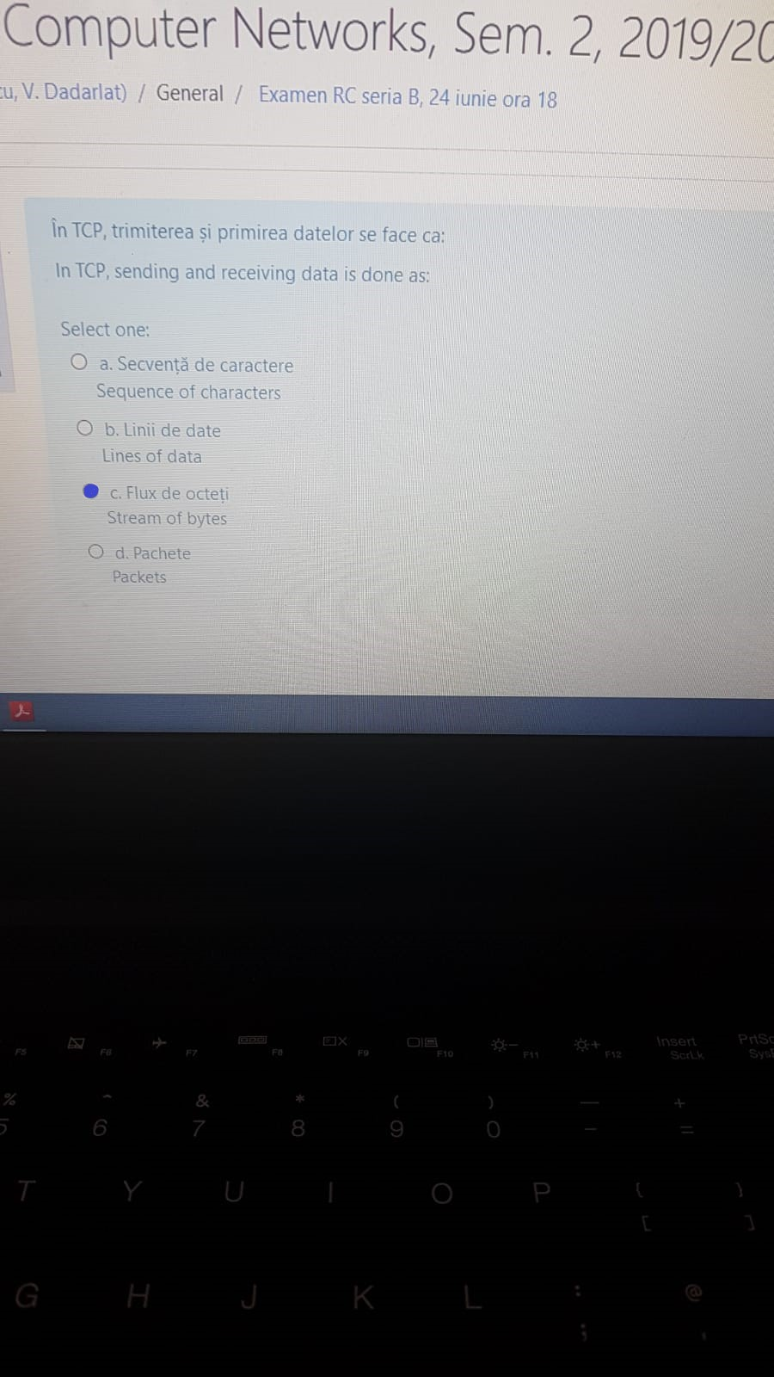
TCP groups a number of bytes together into a structure called :
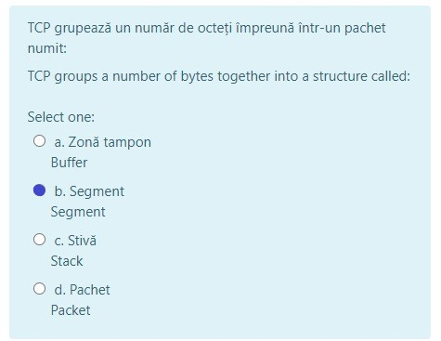
In the sliding window method of flow control, when frames are received
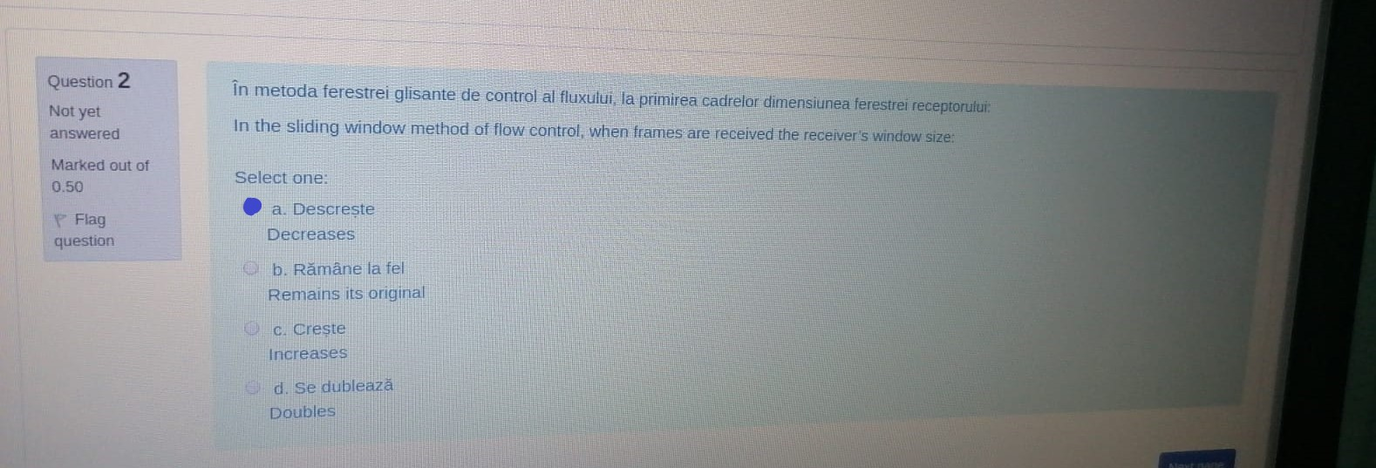
What is the main advantage of UDP
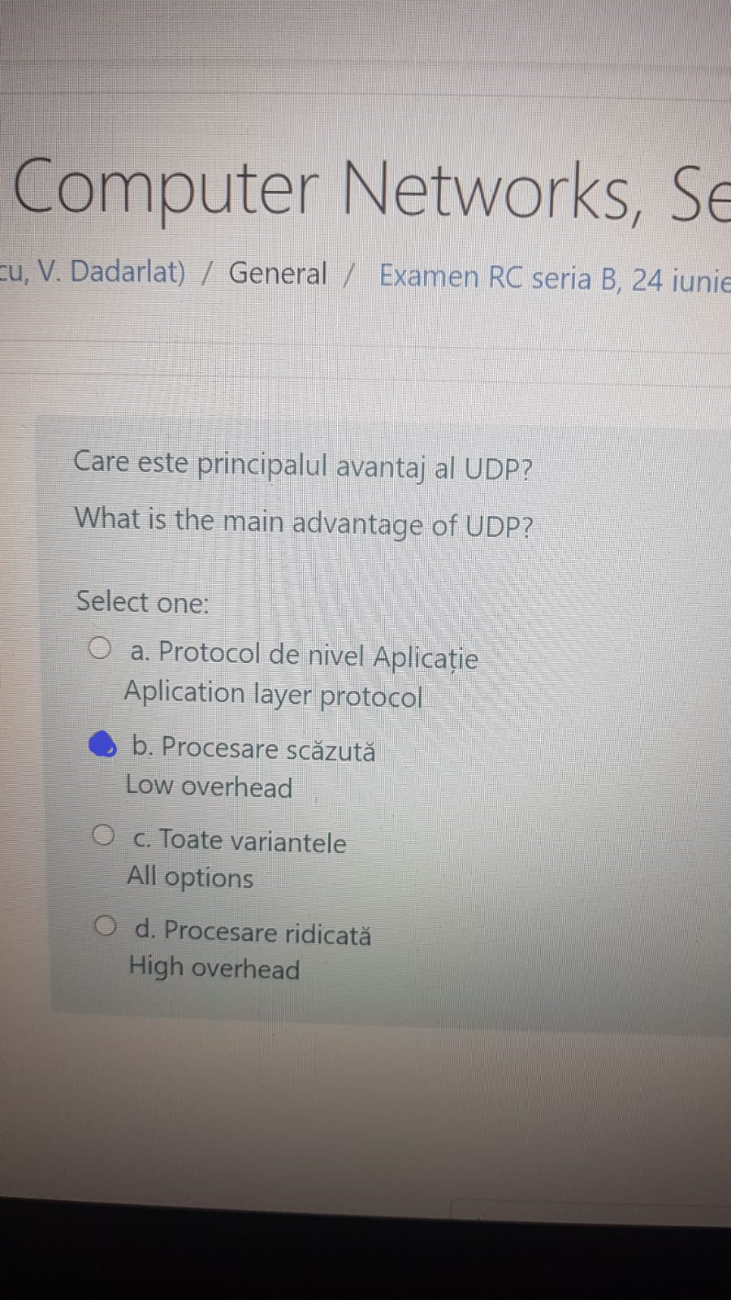
HDLC is
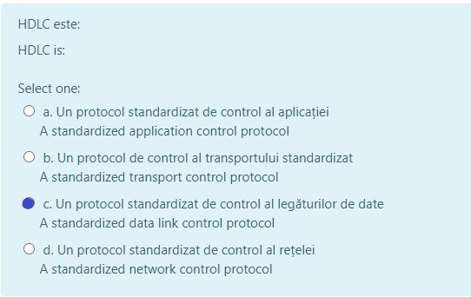
routing techniques does not require any information about the network
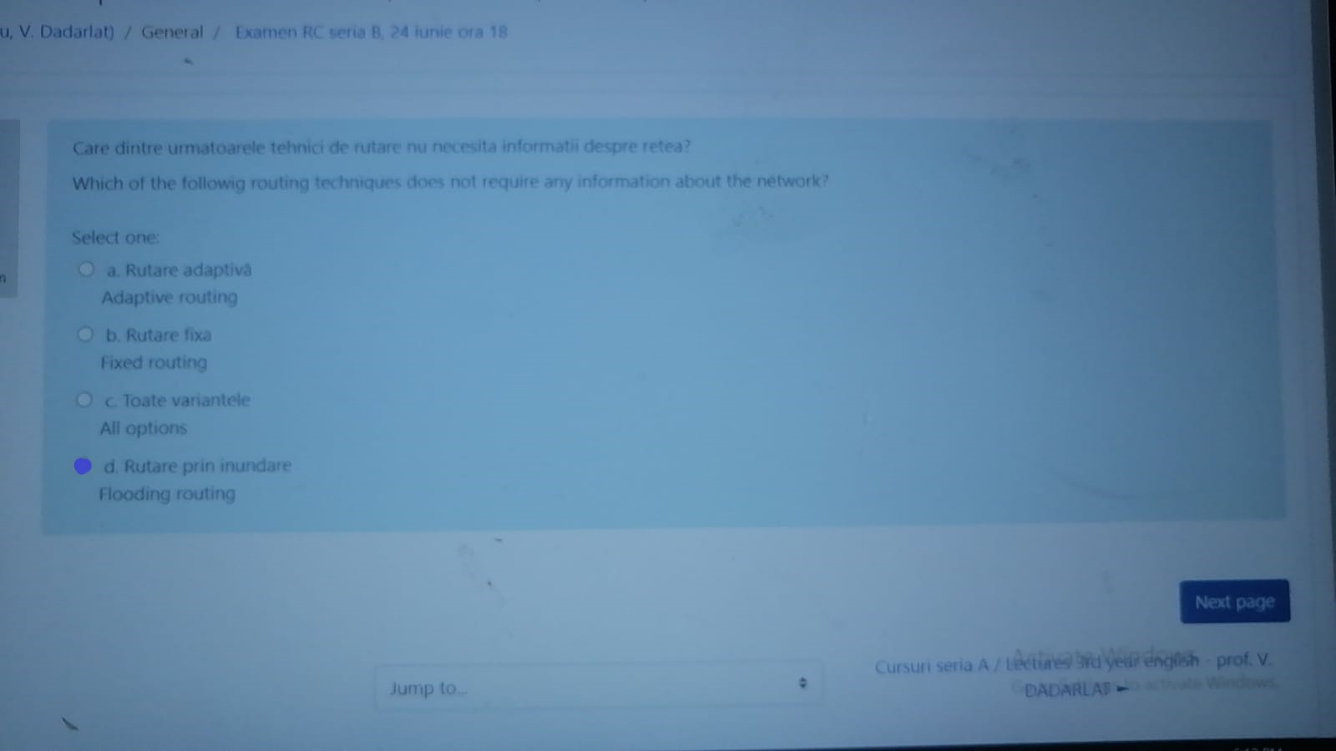
Which multiplexing technique transmits digital signals
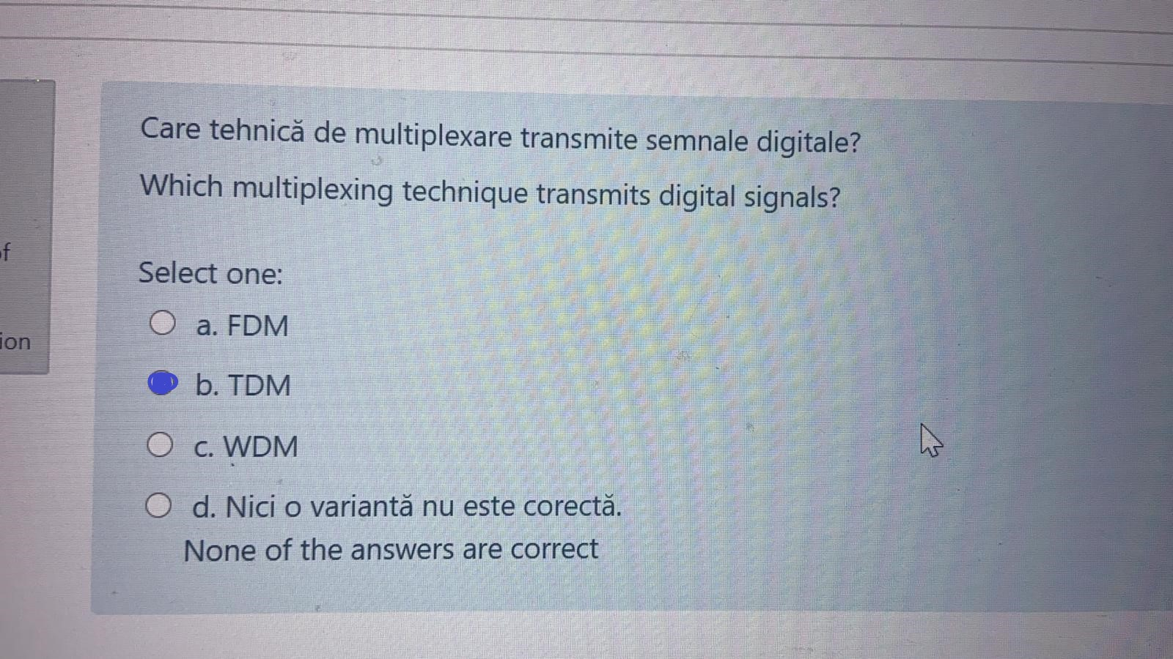
Which multiplexing technique uses light beams

IPv6 anycast addressing is
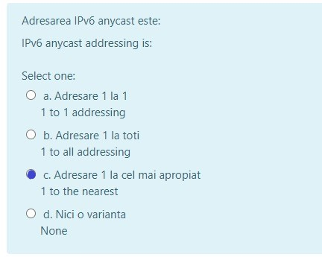
IPv4 addressing which allows communications with a group
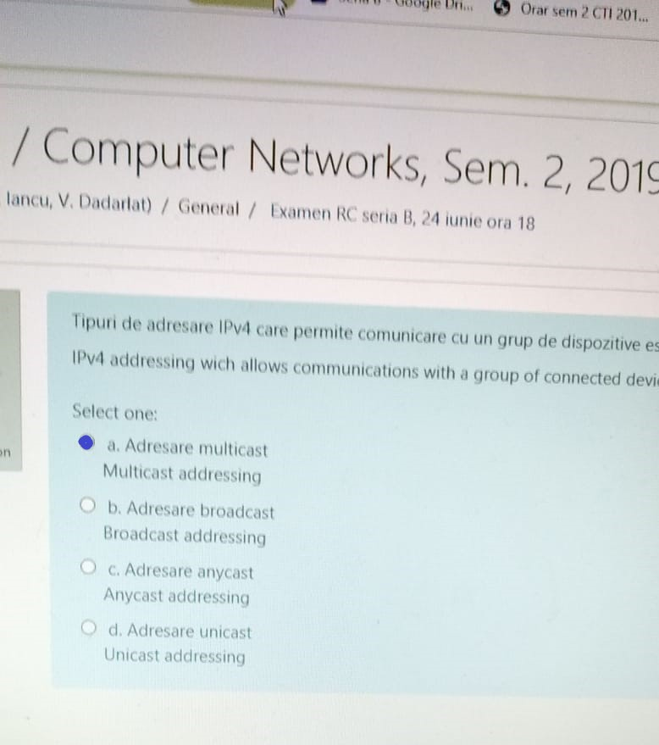
Which of the following routing techniques uses a permanent route between any pair
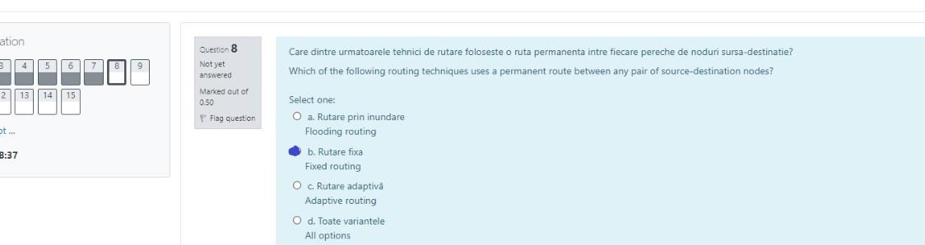
Which field is used to detect errors over the entire user datagram
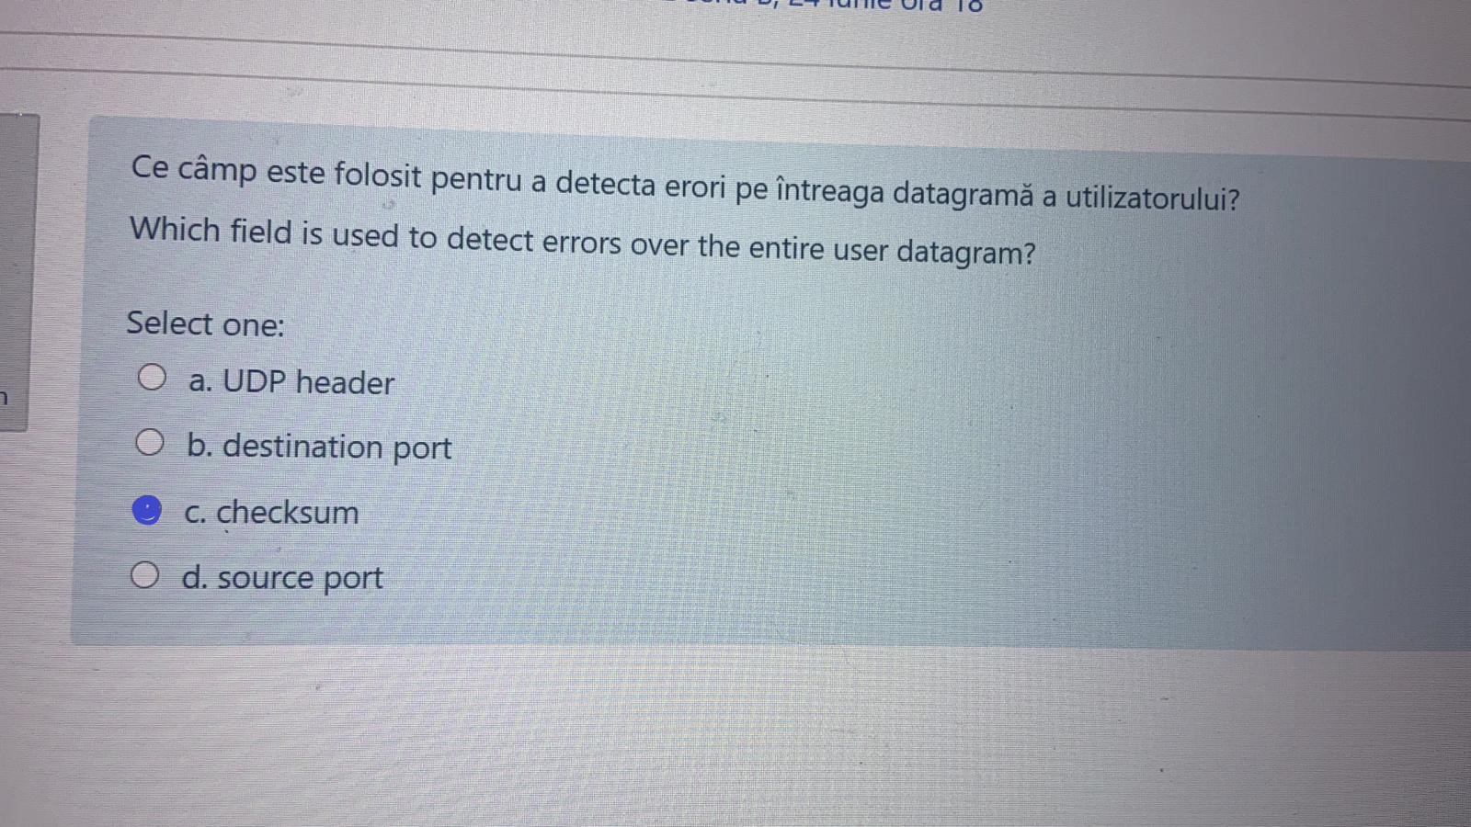
Which one of the following event is not possible in wireless LAN
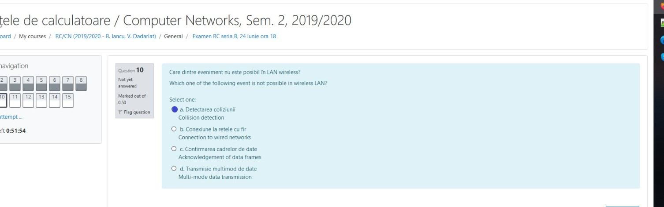
Which multiple access techniques is used by IEEE 802.11 standard for wireless LAN
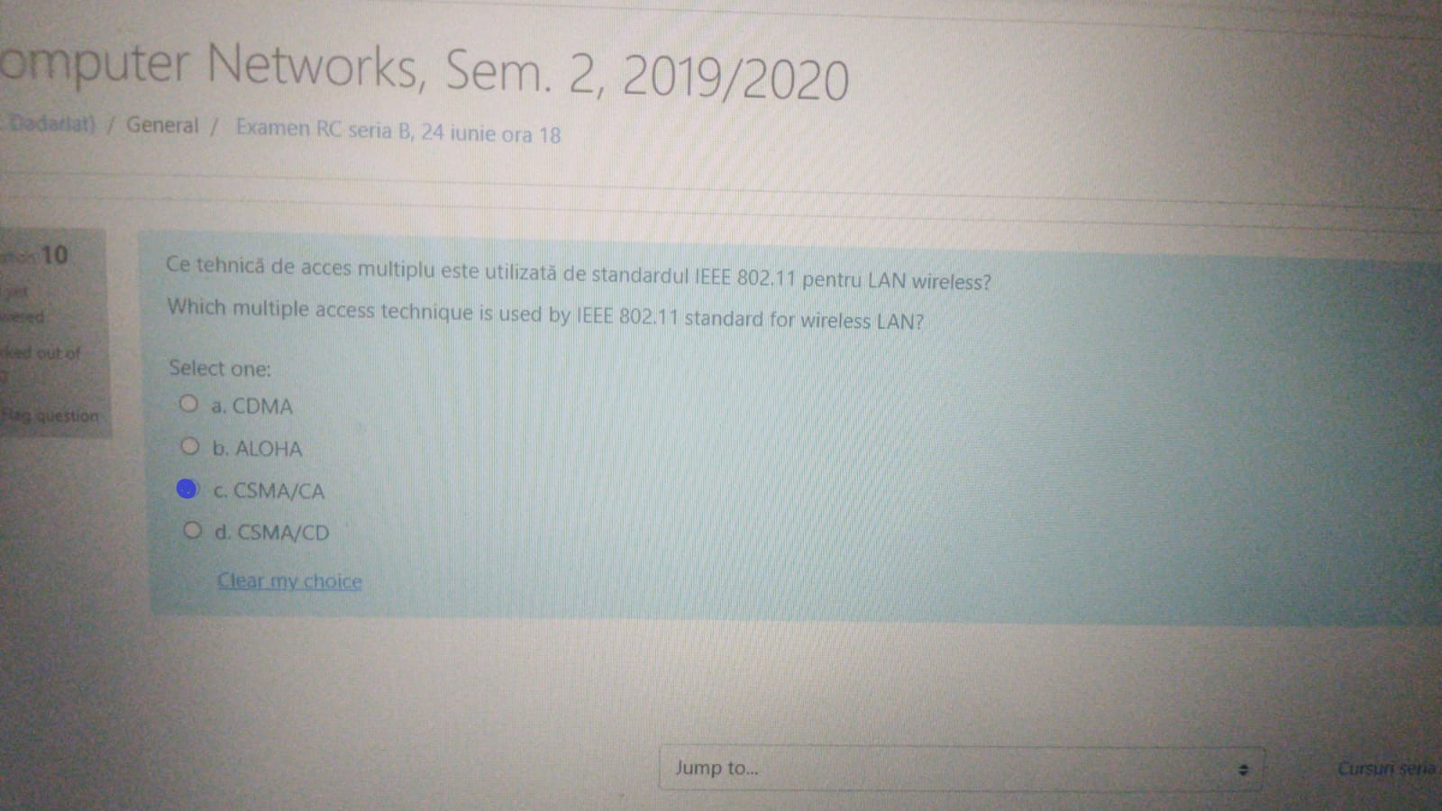
Which multiplexing technique shifts each signal to a different carrier frequency

